भारत मौसम विज्ञान विभाग |  | India Meteorological Department
Saturday 09th May 2026 (19th Vaisakha 1948 Saka)
Summary of observations recorded at 0830 hours IST: The Western disturbance as a cyclonic circulation over northwest Uttar Pradesh and adjoining Uttarakhand lay over East Bihar & neighbourhood between 3.1 and 5.8 km above m. s. l. at 0530 hrs IST of today. It lay as a cyclonic circulation over Sub-Himalayan West Bengal & neighbourhood between 1.5 and 5.8 km above m. s. l. The upper air cyclonic circulation over central Pakistan & adjoining Punjab lay over central parts of Rajasthan at 0530 hrs IST of today. It lay over East Rajasthan at 0.9 km above m. s. l. The trough ran from the upper air cyclonic circulation over central parts of Rajasthan to East Bangladesh across Madhya Pradesh, Jharkhand, Bihar, Gangetic West Bengal at 1.5 km above m. s. l. at 0530 hrs IST of today. It ran from the upper air cyclonic circulation over East Rajasthan to East Jharkhand across Madhya Pradesh Chhattisgarh at 0.9 km above m. s. l. The trough in easterly ran from upper air cyclonic circulation over Comorin area & neighbourhood to southwest Madhya Pradesh across Lakshadweep, Kerala, Karnataka, interior Maharashtra at 0.9 km above m. s. l. at 0530 hrs IST of today. It ran from the upper air cyclonic circulation over southeast Arabian Sea & adjoining Lakshadweep off Kerala coast to Marathwada across coastal Karnataka, north interior Karnataka, and Madhya Maharashtra at 0.9 km above m. s. l. The upper air cyclonic circulation over southwest Uttar Pradesh & neighbourhood lay over West Uttar Pradesh & neighbourhood at 1.5 km above m. s. l. An upper air cyclonic circulation lay over Comorin area & neighbourhood and extended upto 1.5 km above m. s. l. at 1730 hrs IST of yesterday, the 08th 2026. It persisted and extended upto 5.8 km above m. s. l. An upper air cyclonic circulation lay over southeast Arabian Sea & adjoining Lakshadweep off Kerala coast and extended upto 1.5 km above m. s. l. An upper air cyclonic circulation lay over East Madhya Pradesh & neighbourhood at 1.5 km above m. s. l. The trough from the upper air cyclonic circulation over southwest Uttar Pradesh & neighbourhood to north interior Odisha across East Madhya Pradesh and Chhattisgarh became less marked. The upper air cyclonic circulation over central Assam & neighbourhood lay over east Assam and extended upto 1.5 km above m. s. l. at 0530 hrs IST of today. It became less marked. The upper air cyclonic circulation over south Andaman Sea & neighbourhood became less marked. The trough in westerlies at 7.6 km above m. s. l. ran roughly along Long. 83°E to the north of Lat. 24°N. at 0530 hrs IST of today. It became less marked. A fresh western disturbance is likely to affect Western Himalayan Region from 10th May, 2026.

Maximum Temperature Departures: Yesterday, Maximum temperatures are markedly below normal (< -5.1°C) at few places over Uttar Pradesh, Uttarakhand and Bihar; appreciably below normal (-3.0°C to -5.0°C) at few places over Himachal Pradesh Haryana, Chandigarh & Delhi, East Madhya Pradesh, Coastal Andhra Pradesh & Yanam, Tamil Nadu, Puducherry & Karaikal; at isolated places over Chhattisgarh , Gangetic West Bengal, Odisha and Andaman & Nicobar Islands; below normal (-1.6°C to -3.0°C) at isolated places over East Rajasthan, West Madhya Pradesh, Vidarbha, Marathwada. Telangana, Rayalaseema. They are appreciably above normal (3.1°C to 5.0°C) at isolated places over Assam; above normal (1.6°C to 3.0°C) at few places over Gujarat State, Kerala & Mahe, Lakshadweep; at isolated places over Jammu-Kashmir-Ladakh-Gilgit Baltistan-Muzaffarabad, East Rajasthan, Konkan & Goa, Manipur, Meghalaya. The highest maximum temperature of 44.8°C is reported at Phalodi (Rajasthan).

Hailstorm reported over East Madhya Pradesh, Marathwada, Bihar.

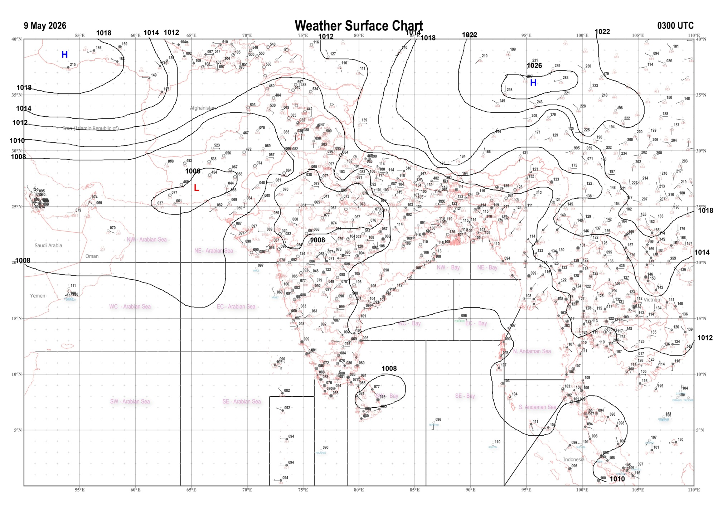 | 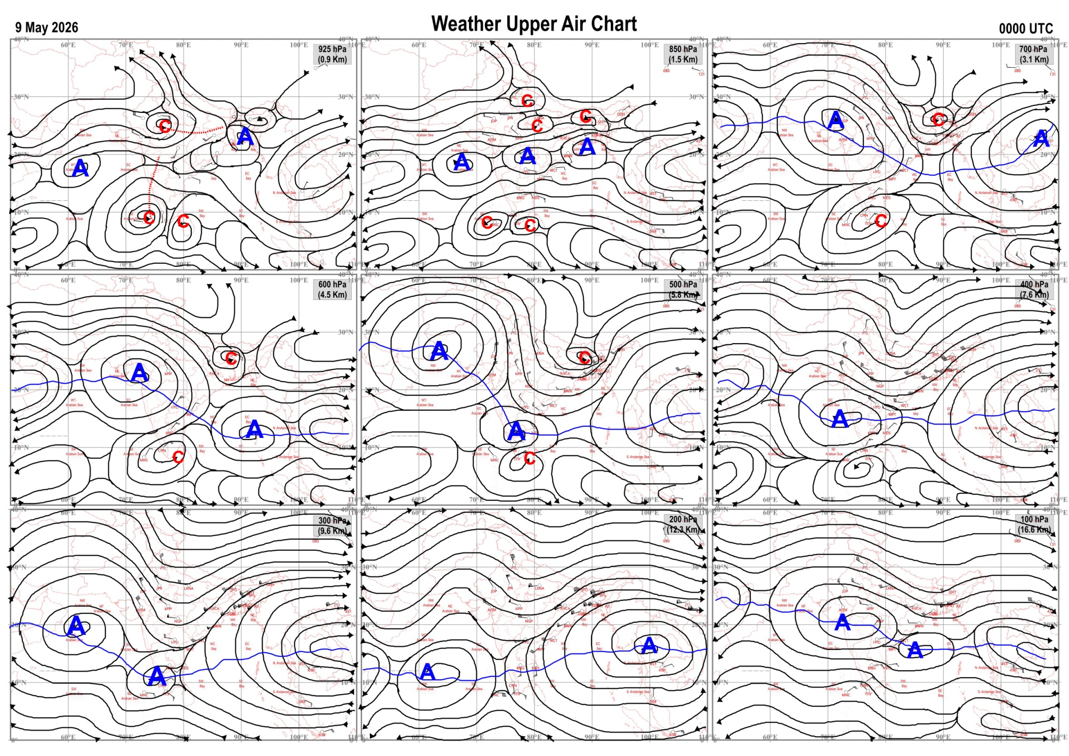
Fig.1. Analysed surface chart based on 03z observation | Fig.2. Analysed upper air chart based on 00z observation
V.K.Shripad
Scientific Officer ‘I’
CR & S Office, Pune  Issued at 1245 hrs. IST |  | Weather Forecasting Division  CR&S, Pune

Indian regions | Realised rainfall (chief amount in cm during past 24 hrs):
East | a few places: Bihar  isolated places: Arunachal Pradesh, Assam & Meghalaya, Nagaland-Manipur-Mizoram-Tripura◆, West Bengal & Sikkim, Odisha and Jharkhand  Williamnagar 5.7, Samastipur 5.2, Sadar chaibasa 5.0, Ghanharia 4.9, Sarasakana 4.7, Gurabandha 4.6, Reamal 3.9, Supaul 3.7, Chaibasa 3.2, Sarusajai ARG & Singimari 2.1 each, Diamond harbour 1.6, Phulbani 1.5, Raiganj PTO 1.4, Balurghat & Jangipur 1.2 each, Kalaikunda (IAF) 0.9, Ziro & Bomdila AWS 0.4 each, Mukto ARG 0.3, Barapani 0.2, Kadamtala ARG & Kohima 0.1 each.
North | isolated places: west Uttar Pradesh, Uttarakhand◆, Himachal Pradesh and Rajasthan  dry weather: east Uttar Pradesh, Haryana, Punjab and Jammu-Kashmir and Ladakh  Sarahan 2.6, Khadrala 1.4, Agra 0.6, Merta city & Tonk vanasthali 0.5 each, Niwai 0.4, Lalitpur 0.2, Khairagarh & Jalore AWS 0.1 each.
Central | isolated places: Madhya Pradesh, Vidarbha and Chhattisgarh  Mohgaon 1.3, Mawai & Yeotmal 1.2 each, Mungaoli & Begumganj 1.0 each, Buldana & Suhela 0.7 each, Malanjkhand & Perseoni 0.5 each, Bhatapara 0.4, Pendra road 0.1.
Peninsula | many places: Kerala+  a few places: Tamil Nadu+++  isolated places: Gujarat Region◆, Konkan & Goa, Madhya Maharashtra, Marathwada, coastal Andhra Pradesh, Telangana, Rayalaseema, coastal Karnataka+ and interior Karnataka  dry weather: Saurashtra & Kutch  Oothu 16.8, Nalumukku 15.8, Puttur HMS 7.2, Kurudamannil 7.0, Karumadi AWS 4.8, Vaibhavwadi 4.5, Trivandrum AP 4.3, Coimbatore south 3.2, Renapur 2.5, Lanja 2.3, Sulya 2.2, Vararamachandrapur 1.8, Koppa 1.7, Tondapur ARG 1.5, Radhanagari 1.3, Udgir IMD parttime & K r nagara 1.2 each, Chimakurthi, Naykal & Mulakalapalle 1.1 each, Venkatagiri & Agumbe AWS 0.8 each, Adilabad 0.7, Jeur IMD parttime 0.6, Vijayapura PTO 0.4, Shahuwadi & Thottambedu 0.3 each, Devgad & Nellore 0.2 each, Silvassa & Indi 0.1 each.
Islands | many places: Lakshadweep  a few places: Andaman & Nicobar  Minicoy 3.7, Nancowry 1.0, Amini 0.4, Hut bay 0.3, Car Nicobar 0.2.
Table-2 Forecast / warnings (distribution of rain / thundershowers) for 7 days (valid from time of origin upto 0830 hrsIST of next day)
Sr N. |  | Sub-division Name | Day 1 | Day 2 | Day 3 | Day 4 | Day 5 | Day 6 | Day 7 | Sr. No. | Sub-division Name | Day 1 | Day 2 | Day 3 | Day 4 | Day 5 | Day 6 | Day 7
 |  |  | 09 May | 10 May | 11 May | 12 May | 13 May | 14 May | 15 May |  |  | 09 May | 10 May | 11 May | 12 May | 13 May | 14 May | 15 May
 | 1 | Andaman Nicobar Islands | F  | F  | F  | F  | F  | F | F | 19 | west Madhya Pradesh | I  | D | D | D + | D + | D | D
 | 2 | Arunachal Pradesh | I | I | S | S + | F + | F + | F + | 20 | east Madhya Pradesh | I  | D | D | D | D | D | D
 | 3 | Assam-Meghalaya | S | S  | F +  | F +  | W+ | W++ | W ++ | 21 | Gujarat region | D + | D + | D + | D + | D + | D + | D
 | 4 | Nagaland-Manipur-Mizoram-Tripura | I | I  | I  | S  | S+ | F + | F + | 22 | Saurashtra and Kutch | D + | D + | D + | D + | D + | D + | D
 | 5 | Sub Him West Bengal/Sikkim | F  | S  | I | W + | W+ | F + | F | 23 | Konkan and Goa | I  + | I + | D | D | D | D | D
 | 6 | Gangetic West Bengal | F  | F  | I  | I | S | S | I | 24 | Madhya Maharashtra | I  | I | I | D | D | D | D
 | 7 | Odisha | I  | I  | I  | I  | I  | I | I | 25 | Marathwada | I  | I  | I | D | D | D | D
 | 8 | Jharkhand | S  | S  | I  | I  | S  | I  | I | 26 | Vidarbha | I  | I  | D | D | D | D | D
 | 9 | Bihar | S  | I  | I  | S  | S  | I | I | 27 | Chhattisgarh | S  | I  | I  | I  | I  | I | I
 | 10 | east Uttar Pradesh | I | D | D | I | I  | I  | I | 28 | Coastal Andhra Pradesh and Yanam | I  | I  | I  | I  | I  | I + | I +
 | 11 | west Uttar Pradesh | D | D | D | I  | I  | I | D | 29 | Telangana | I  | I  | D | D | D | D | D
 | 12 | Uttarakhand | I | I | S  | F | F | S | I | 30 | Rayalaseema | I  | I  | I  | I  | I  | I | S
 | 13 | Haryana,Chandigarh and Delhi | D | D | I  | I  | I  | I | D | 31 | Tamil Nadu, Puducherry and Karaikal | F ++  | S +  | S +  | I +  | S + | F ++ | F ++
 | 14 | Punjab | D | D | I  | I  | I  | I  | D | 32 | Coastal Karnataka | S  | I  | I  | I | I | I | I
 | 15 | Himachal Pradesh | D | D | S  | F | F | S | I | 33 | North interior Karnataka | I  | I  | I  | I | I | I | I
 | 16 | Jammu-Kashmir and Ladakh | D | I | F  | F  | F | S | I | 34 | South interior Karnataka | I  | I  | I  | S  | I | I | I
 | 17 | west Rajasthan | D + | I + | D + | D + | D + | D + | D + | 35 | Kerala and Mahe | W +  | W +  | W+ | W + | W+ | W ++ | W ++
 | 18 | east Rajasthan | I  | D | D  | D+ | D + | D + | D + | 36 | Lakshadweep | W +  | W +  | S  | S  | S  | F | F
Legends: D = Dry I =isolated S = Scattered F = Fairly widespread W = Widespread #= heavy to very heavy rain at a few places with extremely heavy rain at isolated places+++= heavy rain at a few places with very heavy rain at isoIated places++= heavy to very heavy rainfall @=isolated exceptionally heavy rainfall+ = heavy rain ●/*= rain or snow ♦ = very light rain ≡=fog = thunderstorm with lightning =Squall / Gusty / gale / strong wind -=cold wave/cold day + = heat wave/warm night/hot and humid weather =Duststorm =ground frost = Hail.
Fig. 4: Districtwise warnings for five days for Maharashtra State
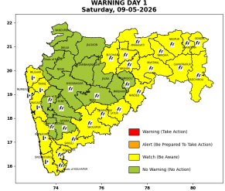 | 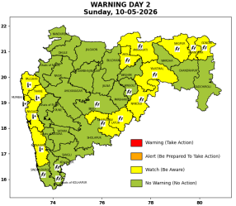 | 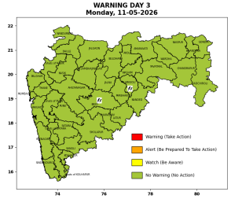 | 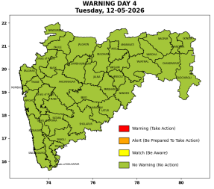 | 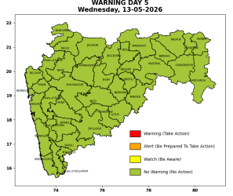

Pune, Lohegaon and Pashan observations at 0830 hrs. IST of Today
 | Temperature (°C) |  |  |  |  | Humidity (%) |  |  |  | Rainfall (mm)
 | Max.  past  24 hrs | Dep.  from  normal | Min.  past  24 hrs. | Dep.  from  normal | Dry  Bulb | At 0830 hrs. IST | Dep.  From  normal | At 1730  hrs. IST of y’day | Dep.  from  normal | Past  24 hrs. | Since  1st March | Dep.  from  normal
PNE | 39.0 | 1.0 | 23.8 | 1.2 | 30.2 | 53 | -3 | 35 | 3 | 0.0 | 92.8 | 73.3
PSN | - | - | - | - | - | - | - | - | - | - | - | -
LHG | 40.0 | 2.0 | 26.5 | 5.5 | 32.4 | 34 | -21 | 17 | -13 | 0.0 | 91.4 | 67.8

 |  |  |  |  |  |  | Local (Pune and neighbourhood) forecast
Max./Min. Temperature (°C) |  |  |  |  |  |  |  |  | Weather
Date | Pune | Pashan | Lohegaon | Chinchwad | Lavale | Magarpatta | NDA | Koregoan park
09/05/26 | 39 / 23.8* | 38 / - | 39 / 26.5* | 37 / 26.6* | 37 / 24.1* | 38 / 27.9* | 38 / 23.0* | 40 / 27.1* | Mainly clear sky becoming partly cloudy sky towards afternoon or evening. Thunderstorm with lightning, very light rain very likely.
10/05/26 | 39 / 24 | 38 / 23 | 40 / 27 | 38 / 27 | 38 / 24 | 38 / 27 | 38 / 23 | 40 / 27 | Mainly clear sky becoming partly cloudy sky towards afternoon or evening.
11/05/26 | 39 / 24 | 38 / 23 | 40 / 27 | 38 / 27 | 38 / 24 | 38 / 27 | 38 / 23 | 40 / 27 | Mainly clear sky becoming partly cloudy sky towards afternoon or evening.
12/05/26 | 39 / 24 | 38 / 23 | 40 / 27 | 38 / 27 | 38 / 24 | 38 / 27 | 38 / 23 | 40 / 27 | Mainly clear sky becoming partly cloudy sky towards afternoon or evening.
13/05/26 | 40 / 25 | 39 / 24 | 41 / 27 | 39 / 27 | 39 / 25 | 39 / 27 | 39 / 24 | 41 / 27 | Mainly clear sky becoming partly cloudy sky towards afternoon or evening.
14/05/26 | 40 / 25 | 39 / 24 | 41 / 27 | 39 / 27 | 39 / 25 | 39 / 27 | 39 / 24 | 41 / 27 | Mainly clear sky becoming partly cloudy sky towards afternoon or evening.
15/05/26 | 40 / 25 | 39 / 24 | 41 / 27 | 39 / 27 | 39 / 25 | 39 / 27 | 39 / 24 | 41 / 27 | Mainly clear sky becoming partly cloudy sky towards afternoon or evening.
Rainfall Distribution |  |  |  |  | Rainfall Categories | Rainfall (mm) | Cloud condition |  | Rainfall Intensity | Range
Widespread (W) | 76-100% |  |  |  | Very Light rain | Trace to 2.4 mm | Mainly clear sky | 1-2 oktas | Light Spell | 1 cm/hr
 |  |  |  |  | Light rain | 2.5 to 15.5 mm | Partly cloudy sky | 3-4 oktas | Moderate Spell | 1-2 cm/hr
Fairly Widespread (FW) | 51 – 75% |  |  |  | Moderate rain | 15.6 to 64.4 mm | Generally cloudy sky | 5-7 oktas | Intense Spell | 2-3 cm/hr
Scattered (S) | 26 – 50% |  |  |  | Heavy rain | 64.5 to 115.5 mm | Overcast | 8 oktas | Very Intense Spell | 3-5 cm/hr
Isolated (I) | 1 – 25% |  |  |  | Very heavy rain | 115.6 to 204.4 mm |  |  | Extremely Intense Spell | 5-10 cm/hr
Dry (D) | No Rain |  |  |  | Extremely heavy rain | ≥ 204.5 mm |  |  | Cloudburst | > 10 cm/hr
Probability Terms in %: |  |  |  |  | Heavy snow | 6.5 to 11.5 cms water equivalent of rain
unlikely | < 25 |  |  |  | Very heavy snow | 11.6 to 20.4 cms water equivalent of rain
likely | between 25 50
very likely | between 51 75
most likely | >75
* = realized temperatu
Mumbai (Colaba) |  |  |  | Nagpur (AP)
Date 2026 | T max °C | T min °C | Weather | T max °C | T min °C | Weather
09/05/26 | 34 | 28 | Mainly clear sky. Hot and Humid. | 41 | 22 | Thunderstorm with rain. Thundersquall with wind speed reaching(50-60kmph).
10/05/26 | 35 | 29 | Mainly clear sky. Hot and Humid. | 42 | 23 | Mainly clear sky. Thunderstorm accompanied with lightning & gusty winds(40-50kmph).
11/05/26 | 34 | 29 | Clear sky. | 43 | 24 | Mainly clear sky.
12/05/26 | 34 | 29 | Clear sky. | 44 | 24 | Mainly clear sky.
13/05/26 | 34 | 28 | Clear sky. | 44 | 25 | Partly cloudy sky.
14/05/26 | 34 | 28 | Clear sky. | 44 | 25 | Mainly clear sky.
15/05/26 | 34 | 28 | Clear sky. | 44 | 26 | Mainly clear sky.

